2

/12/24, 9:57 PM

Docker Playground

cn52u547_cn52u9s7vdo000dm7o8g

192.168.0.28

OPEN PORT

[**8**](http://ip172-18-0-20-cn52u547vdo000dm7o80-32768.direct.labs.play-with-docker.com/)

**3276**

75.04

)

% (2.931GiB / 3.906GiB

%

0.56

ssh ip172-18-0-20-cn52u547vdo000dm7o80@

**

DELETE

**

EDITOR

IP

Memory

CPU

SSH

+

ADD NEW INSTANCE

192.168.0.28

node1

02:18:19

Instances

CLOSE SESSION

**

**

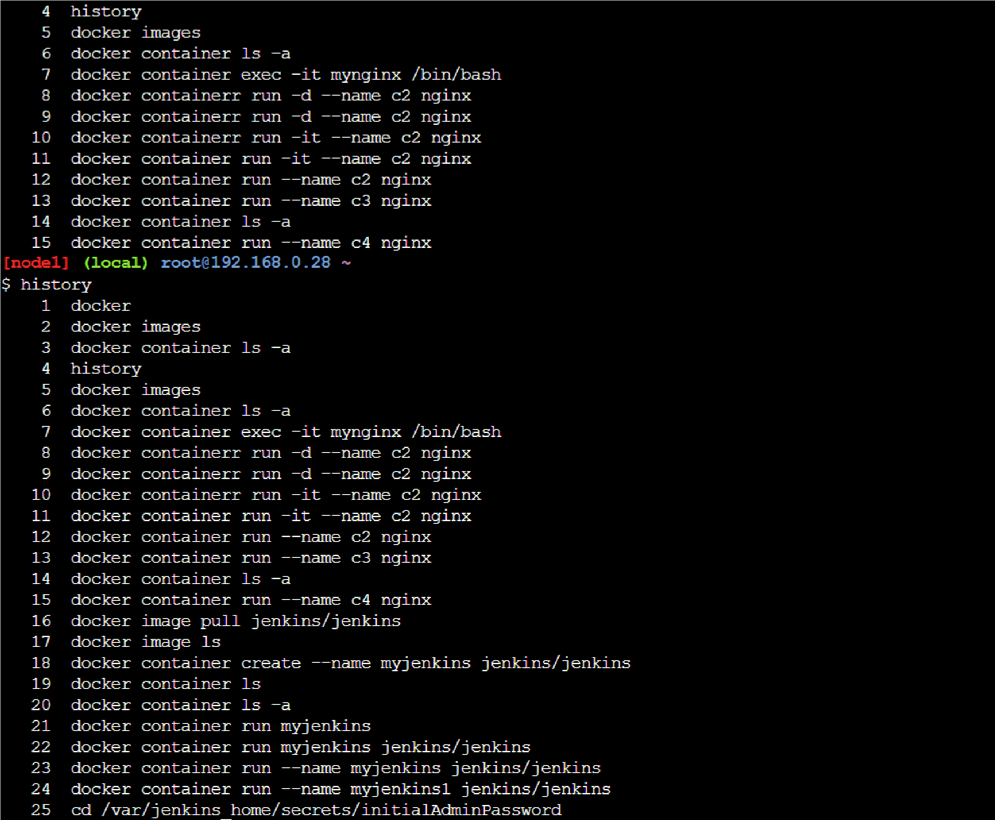

https://l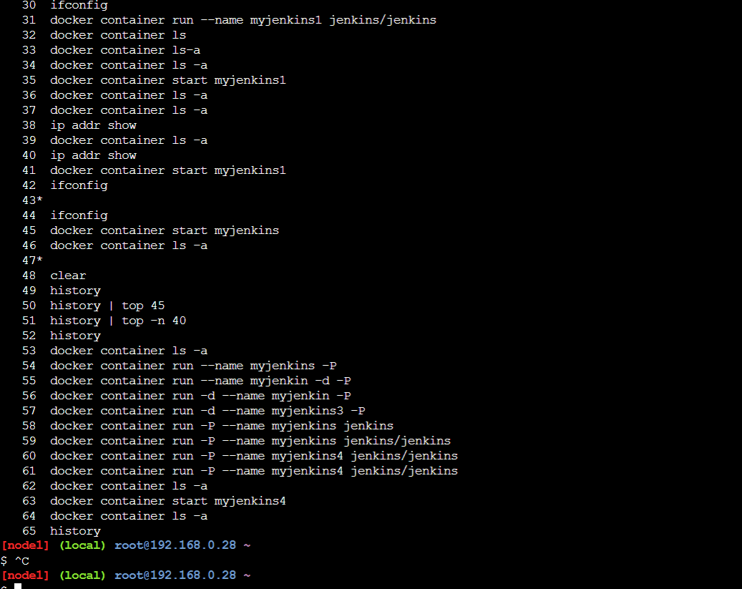abs.play-with-docker.com/p/cn52u547vdo000dm7o80#cn52u547_cn52u9s7vdo000dm7o8g 1/1